SERVICE WORKERS (5 SCENARIOS)

1. A news website should load the last-read articles even when the user is offline. Which Service Worker features would you use and how?
A news website should load the last-read articles even when the user is offline.
Service Worker features used
- Cache Storage API
- Fetch event
- IndexedDB (optional, for article data)
- Offline caching
How it works
- When the user reads an article online, the Service Worker:
  - Intercepts the network request using the fetch event
  - Saves the article’s HTML, CSS, images, or API response into cache
- When the user goes offline:
  - The Service Worker serves the cached article instead of making a network request
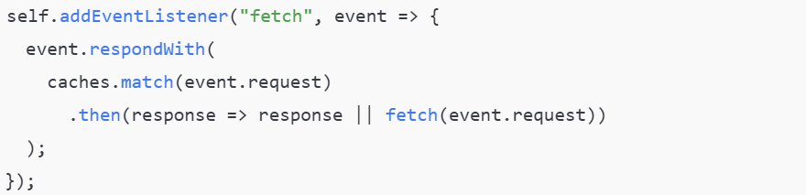

2. Your app fetches API data frequently. You want to serve cached data first and update it in the background. Which caching strategy will you choose?
- Show cached data immediately
- Update data in the background
Best caching strategy
-> Stale-While-Revalidate
Why this strategy?
- Fast user experience
- Fresh data gets updated silently
How it works
- Serve data from cache first
- Fetch latest data from network in the background
- Update the cache with fresh data
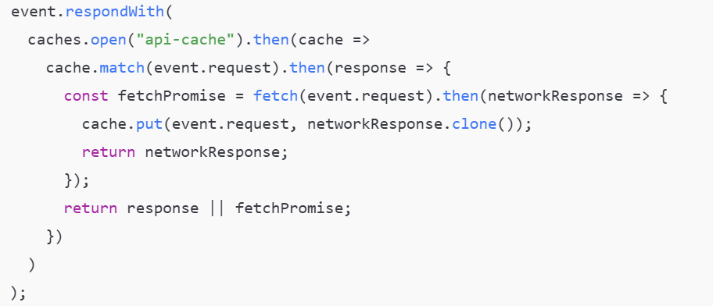

3. A Service Worker is registered successfully, but it is not controlling the page. What could be the reasons?
i. Page was loaded before Service Worker registration
- Service Workers only control pages after refresh
Fix: Reload the page

ii. Scope issue
- Service Worker controls only files within its scope
Fix: Place Service Worker in root or adjust scope
iii. Service Worker is waiting
- A new Service Worker waits until the old one is inactive
Fix:
iv. Not using HTTPS
- Service Workers require HTTPS (except localhost)

4. You updated your Service Worker code, but users still see the old cached content. How would you fix this?
Problem: Browser is serving old cache even after Service Worker update
Fixes
i. Version your cache
ii. Delete old caches during activation
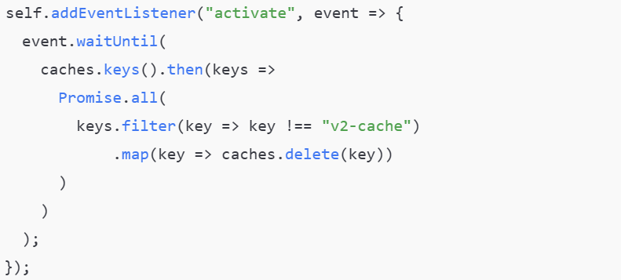
iii. Force new Service Worker to activate

Ensures users get latest content immediately.

5. A shopping app must show a custom offline page when the network fails. How would you implement this using a Service Worker?
Show a custom offline page when network fails
Steps to implement
i. Cache offline page during install
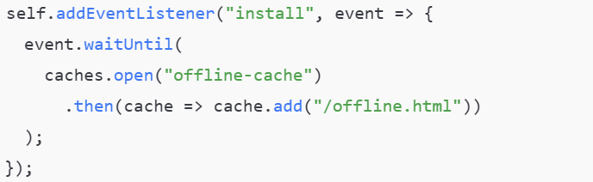
ii. Serve offline page when fetch fails
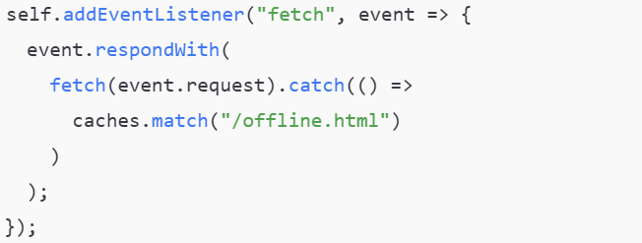

STYLING: TEXT, LINKS, BACKGROUNDS & BORDERS (5 SCENARIOS)

6.You want all links to:
A.be blue by default
B.turn red on hover
C.remove underline except on hover
How would you write the CSS?
Requirements
- Blue by default
- Red on hover
- No underline normally
- Underline only on hover
CSS
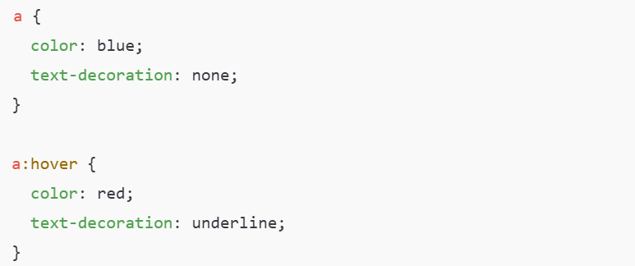
- color → controls link color
- text-decoration → controls underline
- :hover → applies styles when mouse is over the link

7.A heading text must be centered horizontally and vertically over a background image. Which CSS properties would you use?
Best CSS properties
- display: flex
- justify-content
- align-items
- background-image
CSS
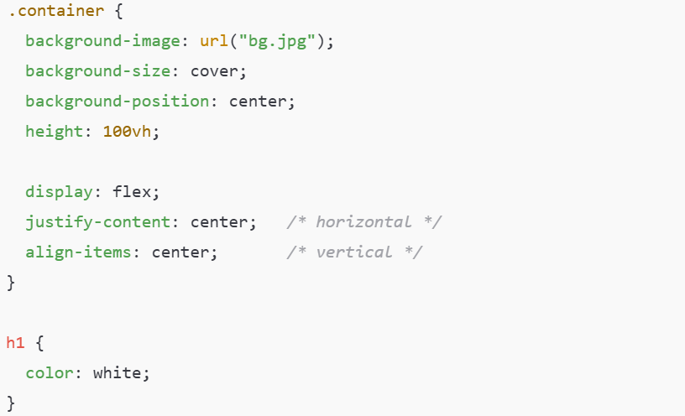
Why Flexbox? Easiest and most reliable way to center content both ways

8.You need a gradient background instead of an image to reduce load time. How would you create it using CSS3?
Use: linear-gradient or radial-gradient
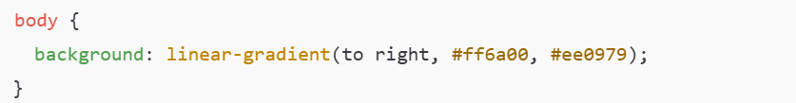
Benefits
- No image download
- Faster loading
- Fully responsive
Other option:

9.A card design requires:
rounded corners
a dashed border
shadow only at the bottom
How would you style it?
Requirements
- Rounded corners
- Dashed border
- Shadow only at the bottom
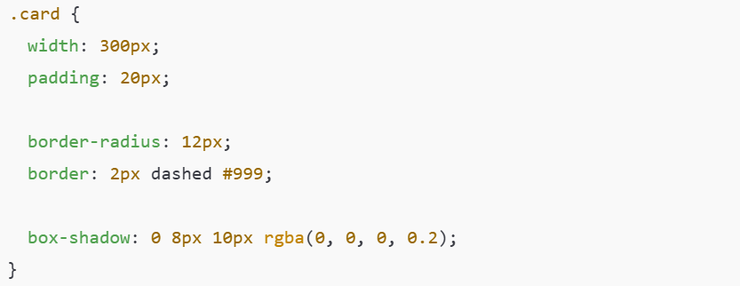
- border-radius → rounded corners
- border: dashed → dashed border
- box-shadow: 0 8px 10px → shadow at bottom only

10.A paragraph text must appear justified, with increased line spacing and custom font color. Which properties will you use?
Requirements
- Justified text
- Increased line spacing
- Custom font color

CSS
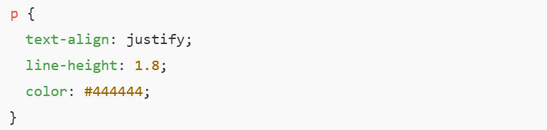
- text-align: justify → aligns text on both sides
- line-height → controls spacing between lines
- color → text color

WHAT’S NEW IN CSS3 (5 SCENARIOS)

11. You want to animate a button smoothly when hovered without using JavaScript. Which CSS3 features will you use?
CSS3 features used:
- transition
- :hover pseudo-class
CSS3 transition allows smooth animation when a property changes (such as color, size, or position) during hover.
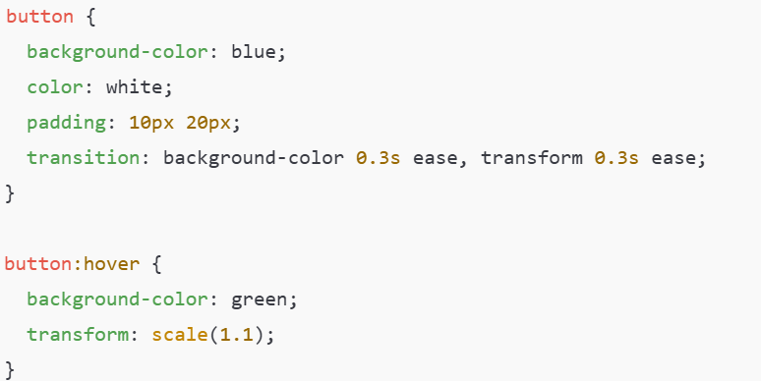

12. A website needs rounded images and soft shadows that work on modern browsers. Which CSS3 properties help?
CSS3 properties used:
- border-radius
- box-shadow
border-radius rounds image corners, and box-shadow adds a soft shadow effect.
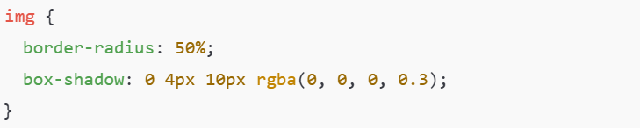
13. You are building a form and want input fields to change border color smoothly when focused. How can CSS3 transitions help?
CSS3 feature used:
- transition
- :focus pseudo-class
CSS3 transitions smoothly animate border color changes when an input field gains focus.
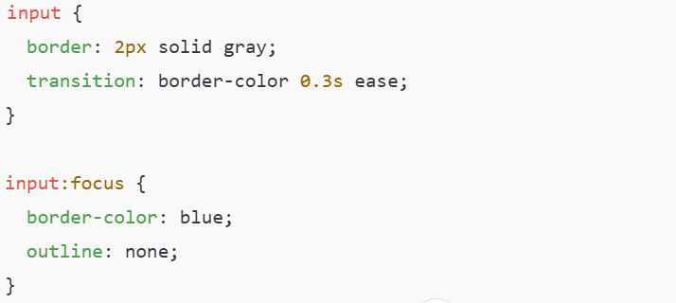

14. A designer wants multiple background images on a single div. Is this possible in CSS3? How?
Yes, it is possible.
CSS3 feature used:
- Multiple background-image values
CSS3 allows multiple backgrounds separated by commas.
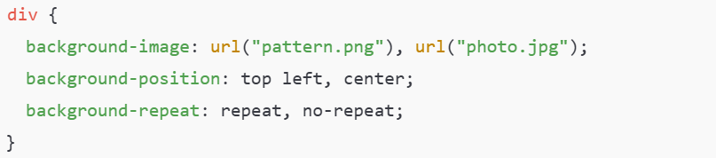

15. To improve responsiveness, you want font sizes to adjust automatically based on screen size. Which CSS3 units or techniques will you use?
CSS3 units / techniques used:
- vw (viewport width)
- vh (viewport height)
- rem
- clamp()
These units automatically scale text based on screen size.
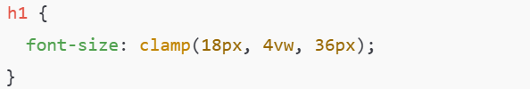

BOX MODEL & LAYOUT (5 SCENARIOS)

16. A div with width: 300px becomes larger than expected after adding padding and border. Why does this happen and how do you fix it?
By default, CSS uses the content-box box model.
This means:
Total Width = width + padding + border
So when padding and border are added, the actual size increases beyond 300px.
Fix:Use box-sizing: border-box;
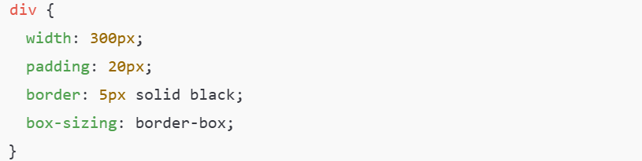

17. Two divs should appear side by side, but they are stacking vertically. What could be the reasons related to box model or layout?
Possible reasons related to layout or box model:
- div elements are block-level elements by default
- Width is not set (each div takes full width)
- display is not changed to inline-block or flex
- Parent container is not using flexbox or grid
Solutions:
Option 1: Flexbox
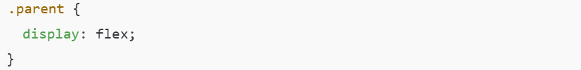
Option 2: Inline-block
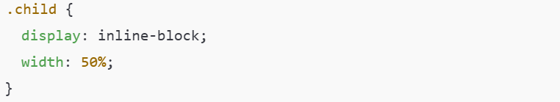

18. A layout breaks on small screens because elements overflow their container. How does box-sizing help?
Problem: Padding and border add extra size, causing overflow.
How box-sizing helps: Using border-box ensures padding and border stay inside the defined width.
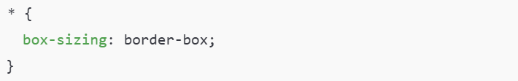
Result:
- No unexpected overflow
- Responsive layouts remain stable

19. You want equal spacing inside a container without increasing its total width. Which box model concept is important here?
Important box model concept: Padding with box-sizing: border-box
Padding creates space inside the element.
With border-box, padding does not increase total width.
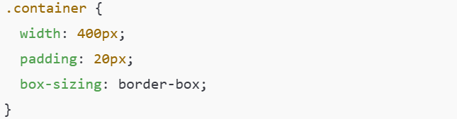

20. A developer uses margin-top on a child element, but it affects the parent instead. What box model behavior is this and how can it be avoided?
Box model behavior: Margin Collapsing
Vertical margins of parent and first/last child collapse into a single margin.
How to avoid it:
- Add padding or border to parent
- Use overflow: hidden or auto
- Use display: flex on parent
